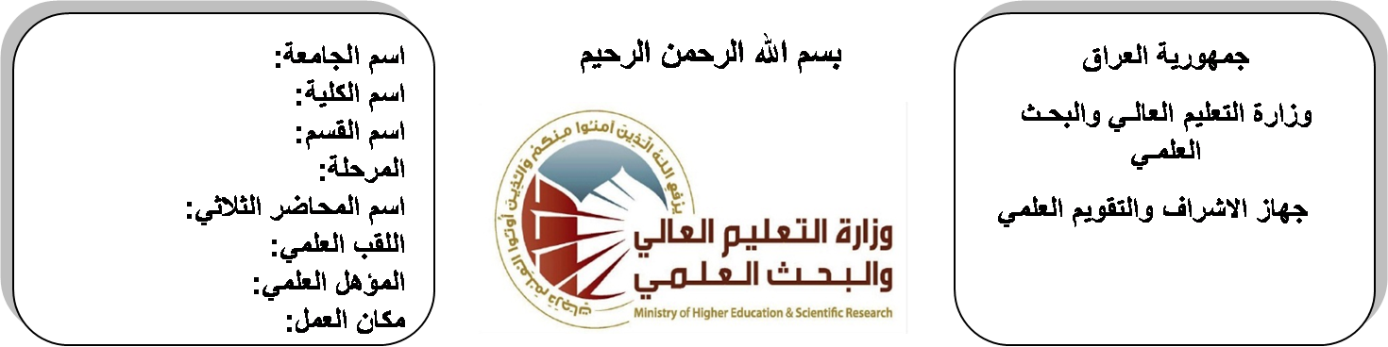

**اسم الجامعة:ديالى**

**اسم الكلية:الهندسة**

**اسم القسم: الالكترونيك**

**المرحلة: الثانية**

**اسم المحاضر الثلاثي: حسن سعد الله**

**اللقب العلمي: مدرس مساعد**

**المؤهل العلمي: ماجستير**

**مكان العمل: كلية الهندسة**

**(( استمارة الخطة التدريسية السنوية ))**

|  |  |  |  |  |
| --- | --- | --- | --- | --- |
| **حسن سعد الله ناجي** | | | | **اسم التدريسي:** |
| **Hassan_sn@yahoo.com.** | | | | **البريد الالكتروني:** |
| Electromagnetic Fields | | | | **اسم المادة:** |
| **The aim of this subject is to make the students ready to undestand and comprehend the scientific theories and their applications related to their field of the study.** | | | | **أهداف المادة:** |
| ***Engineering Electromagnetics***  ***Sixth Edition***  ***William H. Hayt, Jr. . John A. Buck*** | | | | **الكتب المنهجية:** |
|  | | | | **المصادر الخارجية:** |
| **الامتحان النهائي** | **المختبرات** | **الفصل**  **الثاني** | **الفصل الأول** | **تقديرات الفصل:** |
| 60% | 0% | 20% | 20% |
|  | | | | **معلومات إضافية:** |

**جدول الدروس الأسبوعي – الفصل الدراسي الأول**

|  |  |  |  |  |  |
| --- | --- | --- | --- | --- | --- |
| **الملاحظات** | **المادة العملية** | **المادة النظرية** | **التاريخ** | | **الأسبوع** |
| **الملاحظات** | **المادة العملية** | **المادة النظرية** | **التاريخ** | | **الأسبوع** |
|  |  | The Cartesian coordinate system ,vector components and unit | **30/9/2015** | | 1 |
|  |  | vector field dot product, cross product, circular cylindrical coordinate system, spherical coordinate system | **7/10/2015** | | 2 |
|  |  | Coulombs law and electric field intensity-filed of n point charge | **14/10/2015** | | 3 |
|  |  | field due to continuous volume charge distribution | **21/10/2015** | | 4 |
|  |  | field of line charge. Field of sheet of charge , streamline and sketches of fields , electric flux density. | **28/10/2015** | | 5 |
|  |  | Electric flux density , gauss law–application of gauss law | **4/11/2015** | | 6 |
|  |  | differential volume element–divergence , Maxwell first equation. | **11/11/2015** | | 7 |
|  |  | Energy & potential energy expended in moving appoint charge | **18/11/2015** | | 8 |
|  |  | the line integral- definition of potential difference &potential, the potential field of point charge the potential field of system charge | **25/11/2015** | | 9 |
|  |  | Conservative property, potential gradient. The dipole. | **2/12/2015** | | 10 |
|  |  | Conductors, dielectrics & capacitance. Current &current density | **9/12/2015** | | 11 |
|  |  | , continuity of current metallic conductors. Conductor properties &boundary condition | **16/12/2015** | | 12 |
|  |  | method of image semiconductors . Nature of dielectric material | **23/12/2015** | | 13 |
|  |  | Poisson &lap lace equation . examples of the solution of lap lace equation (1-D) , examples of the solution of Poisson's equation (1-D) | **30/12/2015** | | 14 |
|  |  | Boit-savart law , amperes circulate . Curl stokes theorem. Magnetic flux & magnetic flux density | **6/1/2016** | | 15 |
| العطلة الربيعية | | | |  | |

**توقيع الأستاذ: توقيع رئيس القسم توقيع العميد:**

**جدول الدروس الأسبوعي – الفصل الدراسي الثاني**

|  |  |  |  |  |
| --- | --- | --- | --- | --- |
| **الملاحظات** | **المادة العملية** | **المادة النظرية** | **التاريخ** | **الأسبوع** |
|  |  | Boit-savart law , amperes circulate . Curl stokes theorem. Magnetic flux & magnetic flux density | **17/2/2016** | 1 |
|  |  | Derivation of steady – magnetic field laws | **24/2/2016** | 2 |
|  |  | magnetic forces | **2/3/2016** | 3 |
|  |  | Force on moving charge | **9/3/2016** | 4 |
|  |  | force on differential current element | **16/3/2016** | 5 |
|  |  | force between differential current elements | **23/3/2016** | 6 |
|  |  | force and torque and torque on a closed circuit | **30/3/2016** | 7 |
|  |  | Magnetization and permeability | **6/4/2016** | 8 |
|  |  | Magnetization and permeability | **13/4/2016** | 9 |
|  |  | magnetic boundary condition | **20/4/2016** | 10 |
|  |  | the magnetic boundary condition | **27/4/2016** | 11 |
|  |  | the magnetic circuit | **4/5/2016** | 12 |
|  |  | potential energy | **11/5/2016** | 13 |
|  |  | force on magnetic materials | **19/5/2016** | 14 |
|  |  | force on magnetic materials | **26/5/2016** | 15 |
|  |  | inductance and mutual inductance | **3/6/2016** | 16 |

**توقيع الأستاذ: توقيع رئيس القسم توقيع العميد:**